Luxulyan School Newsletter

Friday 6th October 2017
ADDRESS: Luxulyan School, Luxulyan, Bodmin, Cornwall, PL30 5EE
TEL: 01726 850397 EMAIL: head@luxulyansch.org WEBSITE: www.luxulyan.eschools.co.uk

Please note some activities/events are not connected to Luxulyan School and parents should undertake their own checks as to the suitability of the providers/activities.

ASH CLASS
We have been learning all about the story of 'The Three Little Pigs' over the past two weeks. The children have constructed small houses using straw, sticks and wooden bricks, then worked together to build a strong, wolf-proof house using our big construction blocks. This week, the children innovated their own story 'The Three Little Rabbits' and were all able to retell and act it out to Miss Illsley and Mrs Ludwig.
In phonics we have continued to learn and practise new sounds. If you would like more information about the sounds we have been learning then please speak to either of us. In Maths, we have been focusing on number recognition and counting. The children have enjoyed building towers and finding the matching numeral, making birthday cards and going on number treasure hunts.
The children are all doing very well at achieving and working towards gaining their first 'Reading Karate' bands. Please continue to share your child's reading book as often as possible and record it in their reading record. Every read you share together counts!
We currently have PE on Thursday and Friday. Please could we ask you to check that your child has a full PE kit in school; this needs to include a t-shirt, bottoms, socks (if not worn to school) and trainers/plimsolls. If your child attends a sports club after school then we ask, if possible, that they bring a separate change of clothes in for this.
Thank you for your support,
Miss Illsley and Mrs Berry

BEECH CLASS
We've had an exciting time recently, adapting the story of ‘The Very Hungry Caterpillar’ into ‘The Very Ugly Duckling’ and beyond into the children's own versions. The children have worked really hard on including expanded noun phrases in their work, as well as writing their first extended piece of writing.
Another exciting development is our new interactive whiteboard! The children have been really enjoying the new possibilities it brings - along with laughing at Miss Coffee getting used to the new board!
In Maths we have moved from number and place value to addition; learning about fact families using a bar model and part whole model to break numbers up.
Year 2's topic work is still focusing on animals including humans and we have been thinking about the basic needs of all animals - as well as the luxuries we all enjoy!
Miss Coffee

SYCAMORE CLASS
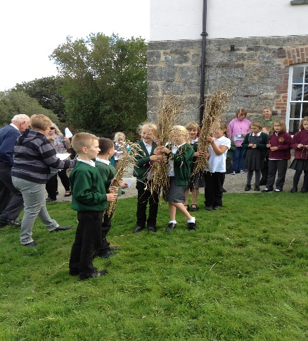

‘What ‘ave ‘ee! What ‘ave ‘ee!’
Over the last two weeks Sycamore class have gained a lot of experienced from two very different activities. Firstly, the Year 3’s took part in ‘Crying the Neck’ at Gunwen Chapel (a ceremony which dates back thousands of years to traditionally celebrate the end of harvest). The children also enjoyed an ‘Arts and Crafts’ session as well. We are very grateful to the Old Cornwall Society who organise the event and hope to take part in next year’s ceremony.
The Year 4 children participated at a Sports Festival hosted by Penrice School. They competed in many different sporting activities during the day including badminton, rowing in the gym, hockey and athletics.
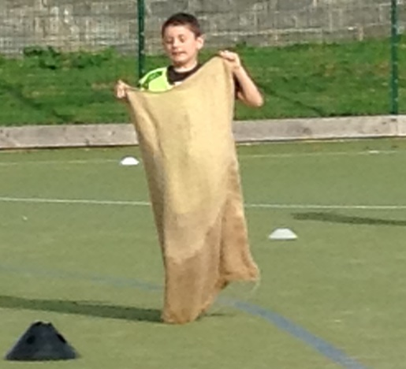
Reece in the sac!
During both events the children’s behaviour was exemplary and they can be hailed as great ambassadors for Luxulyan School- well done everyone!
Mrs Mileham
OAK CLASS
Newsletter Match report:
On Tuesday 3rd October, Year 3, 4, 5 and 6 had a football match and there was a High 5 (Netball) match for the year 5/6 girls. The game took place at St. Dennis
What were the scores:
The Y3/4 football team won their match 2-1.
5/6 football team- stood strong and defended well but lost 5-0.
5/6 High 5 team- played a blinder of a game but lost 9-4.
Everyone enjoyed it but next time we will win both football and netball matches! And by the way Elle M scored 2 goals when she was on in the first quarter.
The next game is on Tuesday the 10th of October and it is at Luxulyan School against Roche. Bring it on!
By Elle and Jessica
To wrap up our topic of Groovy Greeks we have an exciting finale planned for Wednesday 18th October.
In the morning, the children will enter the Spacelab, an inflatable planetarium, exploring the theme of Greek Culture, Myths and Legends. They will learn about star patterns invented by the Greeks and the sky as a cinema for storytelling.
They will hear myths linked to constellations and consider Greek perceptions of the universe. In the afternoon, we will solve an Ancient Greek Mystery. In order to get into the spirit of things, the children are welcome to bring in Ancient Greek costumes, helmets or headdresses to wear.
To end our explorations, we will hold a banquet where the children will be able to taste some Greek food, please ensure we have up to date allergy advice for your children.
Mrs Williams and Mr Heagney

SPORT REPORT
Luxulyan school FC started their season in the Clays school league with two very competitive games against strong St. Dennis opposition.
After the long trip up the A30 the Luxulyan teams were brimming with excitement with the prospect of a first competitive football fixture for many of the players.
Year 3/4 team – St Dennis 1 – 2 Luxulyan
The year 3/4 team set up in a Christmas tree formation with; Isaac in goal, Cody, Ethan and Harry as the defenders, Riley and Bailey as the midfielders and Talon as the striker.
St. Dennis kicked off and immediately after, Luxulyan won the ball and were on the attack for the first of many occasions. The first half saw Luxulyan dominate but had no goals to show for their efforts.
During half time Ethan swapped with Isaac in goal and the team received a quick tactical talk with Mr LDL. Luxulyan started the second half in high spirits and were soon rewarded after 2 minutes when Riley scored a well taken goal. After the celebrations Luxulyan seem to think everyone in the team could score a goal and started to attack in numbers; this left them outnumbered in defence and St. Dennis scored an equaliser 1 minute later. Luxulyan defended well against a rejuvenated St. Dennis team but gave away a penalty after a trip in the box. Ethan looked confident in goal and made the St. Dennis penalty taker feel the pressure. The Luxulayn supporters watched nervously as St. Dennis took the penalty and were soon relieved as they watched it sail high and wide past the post. Luxulyan took the resulting goal kick and were still in search for a winning goal. After numerous chances were missed or saved, Riley intercepted a St. Dennis pass and ran at pace to create a 1 on 1 opportunity with the goalkeeper and finished calmly to make it 2-1 with 1-minute left. Luxulyan remained resilient with the team captain Bailey continuing to show real quality as a midfield engine.
Mr LDL’s Players of the match – Bailey, Riley and Talon.
St. Dennis player of the match - Riley
Year 5/6 team – St Dennis 5 – 0 Luxulyan
The year 5/6 team were extremely excited to start the game as many of them were about to experience their very first competitive football fixture.
St. Dennis were an organised outfit and showed early signs of scoring if it wasn’t for brilliant defending from the team with the midfielders Kyran, Lauren and Bailey working tirelessly to help out Oakley and Jamie in defence. The St. Dennis number 6 was a constant threat and soon broke through the defence to make it 1-0. Luxulyan dealt with wave after wave of St. Dennis attack but were beaten twice more to make it 3-0 at half time.
After a quick half time talk and a few position changes Luxulyan kicked off. Kyran and the newly introduced Riley combined well to force some fine defending and indeed saves from the St. Dennis goalkeeper and defence. The energetic St. Dennis number 6 was again on the score sheet in the second half to score his 3rd and set up the 5th to make it 5-0. The Luxulyan team showed real determination not to give up and continually competed with captain Kyran encouraging his players to follow his lead in some outstanding defending. Jamie whilst playing in defence was at hand repeatedly to make some brilliant tackles to foil any St. Dennis shots at goal. The second half goalkeeper Mason made some outstanding saves and received a rapture of applause from the travelling fans on numerous occasions.
Mr LDL’s Players of the match – Kyran, Jamie and Mason
St. Dennis player of the match – Mason
Mr Le-Doux-Lucas
Sports Co-Ordinator

ANNUAL FLU VACCINATION –
RECEPTION – YEAR 4 – 16TH NOVEMBER 2017
All parents of reception age children to Year 4 should have received an Annual Flu Vaccination letter and consent form. Please return the consent form to the school office even if you do not want to vaccinate your child.

A BIG THANK YOU
Luxulyan School would like to say thank you to the Kings Arms for their very kind donation of £100 raised from their harvest festival.

YEAR 6 TRANSFER TO SECONDARY SCHOOL
SEPTEMBER 2018
All pupils in Year 6 should have received the LA produced booklet. Applications must be made by 31st October 2017 and can be completed online at www.cornwall.gov.uk.
We have been asked to point out to parents the importance of naming more than one preference. This will not give them any less chance of securing a place at their preferred school but means that, in the event that the preferred school is oversubscribed, it reduces the chances of being allocated an unnamed school. Further delays and disappointments can occur when a family is allocated the “nearest school with room” but they then wish to state a preference for a different school, which may already be full but could have been allocated had it been named as a preference.

ADMISSION TO A RECEPTION CLASS
SEPTEMBER 2018
If you have a child born between 1st September 2013 and 31st August 2014 you MUST apply for a school place by 15th January 2018. Leaflets are available from the school office or you can apply online at www.cornwall.gov.uk/admissions.

PARENT EVENINGS – WEDNESDAY 11TH OCTOBER AND THURSDAY 12TH OCTOBER
Please make an appointment for parent’s evening on one of the above dates. You can book your appointment by using our appointment sheets in reception.

If you are unable to come in to reception please contact the school office who will be able to book an appointment for you.

CANCELLED CLUBS
Due to parent’s evening there will be no clubs available on Wednesday 11th and Thursday 12th October.

AFTER SCHOOL CLUBS - CHANGES
Due to our school now participating in netball and football matches in the Clay League we have changed our Clubs format to below:

Monday – Choir – lunchtime 12.30pm-1pm (children will eat lunch first) with Mrs Williams

Monday – Gardening with Mrs Berry
3.15pm-4.15pm

Monday – High 5 with Mrs Mileham
3.15pm-4.15pm

Wednesday- Learning Zone with Miss Teobald
3.15pm – 4.15pm

Thursday – Multi Skills with Miss Illsley
3.15pm – 4.15pm

Thursday - Yoga with Miss Coffee
3.15pm – 4.15pm

Thursday – Football with Mr Le-Doux-Lucas
3.15pm-4.15pm

IPADS DONATION FOR COMMUNITY USE
PALS have very kindly donated 9 Ipads to Luxulyan School for use within the community.

We hope to be able to offer sessions to the community in the second half of the Autumn term. Date and times to be confirmed.

SCHOOL DINNERS
We are sorry to tell you that unfortunately, since changing the school dinner contract to Caterlink, we will no longer be able to provide the 5 school dinners for the price of 4.

All school dinners cost £2.30.

PARENT PAY
For parents of current pupils who were with us last year, please could you make sure that you have registered with ParentPay.

This system will be used for ALL methods of payment within the school as we have introduced ParentPay to pay for school lunches on Monday 18th September (if you have paid for lunches using Parentpay before this date this is acceptable.

If you have misplaced your original registration letter, please contact the school office.

Please can parent’s check their Parentpay accounts for any money owed.

Clay Schools Fixtures -
We are very lucky this year to be participating in the Clays school Football and High 5 leagues. Here the fixtures list:

10.10.17 Luxulyan vs Roche

17.10.17 Nanpean vs Luxulyan

07.11.17 Luxulyan vs Whitemoor

14.11.17 Luxulyan vs Foxhole

21.11.17 Bugle vs Luxulyan

09.01.18 Luxulyan vs Treverbyn

We will confirm on a weekly basis whether the Year 3/4 football match will be happening due to team availability within other schools.

Fixtures maybe changed or cancelled due to typical Cornish weather

HEADLICE
We have had a case of headlice this week. We urge ALL PARENTS to check your child(ren)’s head for any signs of head lice. If live lice are found, the wet combing method should be used every 2-3 days for at least 2 weeks (to break the life cycle of head lice) until the problem is cleared.

All family members should be checked and treated if necessary. We suggest that checks should then continue to be made on a weekly basis to prevent any further infestations.

Many thanks

PARENTVIEW
On the website, click on the parents tab, then follow the 'Parent View' hyperlink to share your views.
Parent View gives you the chance to tell Ofsted what you think about your child’s school, from the quality of teaching to dealing with bullying and poor behaviour. The survey can be completed at any time; you don’t have to wait until the school is being inspected.
We will use the information you provide when making decisions about which schools to inspect and when.
Click ‘Give your views’ to register and complete a survey to help your child’s school improve.
MACMILLAN CAKE BINGO

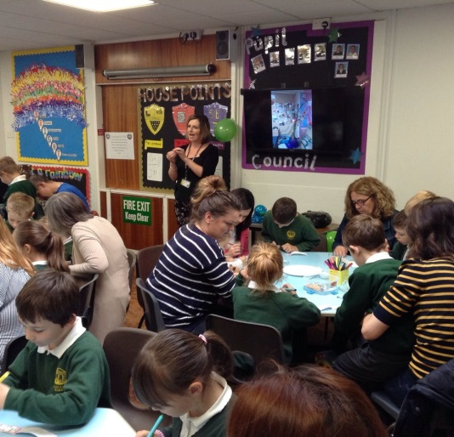

Our Cake Bingo was well attended on the 29th September and lots of fun was had by all. Well done to Sarah Kemp for guessing the height of the cake at 94cm

The children enjoyed the bake sale and Bingo in their classes.

We raised £120 that will help MacMillan carry on doing the fantastic job they do.
Thank you for your continued support at these events.

DIARY DATES
9th October - Harvest Festival
11th October – Parents Evening
12th October – Parent’s Evening
20th October – INSET DAY
29th October-27th October- Half Term
30th October – INSET Day
31st October – INSET Day

9th November – Year 5 Chemistry Science Day at Penrice
16th November – Reception, Y1,2,3,4 Annual Flu Vaccination
17th November – Children in Need
22nd November -1st December – Music and Speech Festival
23rd – 30th November – Book Fair

2nd December – Magic Show @ 4pm
Christmas Tableaux @ 5pm
19th December – Trip to the Cinema
19th December – Christmas Dinner
20th December – Last day of school

4th January 2018 – First day back after the Christmas holiday

STAFF TRAINING DAYS – CLOSED TO PUPILS
Friday 20th October 2017
Monday 30th October 2017
Tuesday 31st October 2017
Monday 23rd July 2018
Tuesday 24th July 2018

