Luxulyan School Newsletter

Friday 10th November 2017

ADDRESS: Luxulyan School, Luxulyan, Bodmin, Cornwall, PL30 5EE
TEL: 01726 850397 EMAIL: head@luxulyansch.org WEBSITE: www.luxulyan.eschools.co.uk

Please note some activities/events are not connected to Luxulyan School and parents should undertake their own checks as to the suitability of the providers/activities.

ASH CLASS
The second half of our Autumn term has started with a bang! In keeping with our new topic, 'Celebrations', the children have been learning about Bonfire Night. We have talked about firework and bonfire safety, created some fantastic firework pictures using paint and chalks and found out about Guy Fawkes and the Gunpowder Plot.
Following the childrens' interests, it was clear that birthdays are a firm favourite. We have transformed our role play area into a birthday party and have been taking part in lots of learning activities with a birthday theme. In literacy, the children have helped to create a recipe for making a birthday cake, using numbered steps and bossy verbs. We then followed the recipe to make our own fairy cakes. In maths, we have been focussing on 2D shapes. Everybody made and decorated saltdough biscuits in different 2D shapes, which have been added to our roleplay area to enhance the birthday party play. After making fairy cakes the children were challenged to design a 2D shape icing design, which they later iced on before being very happily eaten.
Miss Illsley and Mrs Berry
BEECH CLASS
Class 2 have had a great start to the half term with their excellent response to the Meteorite incident. We investigated really well - coming up with many theories and suppositions as to what may have caused the incident. The questions we asked PCSO Jamie were well thought through and

interesting. We have also started our learning of our new story 'Alice in Wonderland' by Lewis Carroll. We have done a great job putting actions to the story and the children have been enthralled hearing about the weird and wonderful characters in the story.
Later on in the term (date to follow) the children will be inviting you to a 'Mad-Hatter's Tea Party'. For this we would like the children to make their own 'mad hat' that they can wear to the event. The hat can be any shape or size, anything that the children ca come up with. Thanks in advance for your support.

Miss Coffee

SYCAMORE CLASS
What a frantic week it has been! A must say a big thank you to each and everyone of my children in Sycamore class who have had many changes introduced to them; you have all coped extremely well. Once the new routines have been established, I am sure that everyone will benefit and will enjoy their learning even more! If any parents or carers have any questions about the new practices please come and talk to me sooner rather than later.
English- A great start with inspiration for a newspaper report taken from our real-life meteor crash.
Maths- As well as consolidating knowledge of place value, Maths has concentrated on learning the times tables- practise makes perfect and the more children practice the more confident they will become in our weekly times tables tests.
Topic work- We launched our new topic this week – The Good The Bad and The Ugly which will entail many strands including the History of Crime and Punishment.
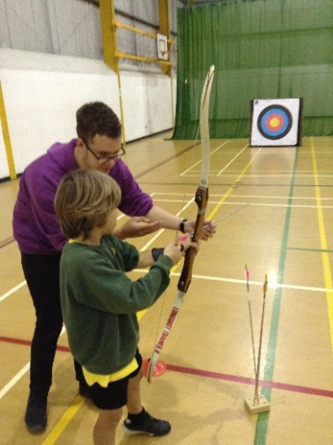
Yesterday the children had a marvellous day out at Duchy College and turned their hand at Archery and Orienteering. Many thanks to Mr Le -Doux – Lucas who organised the visit.
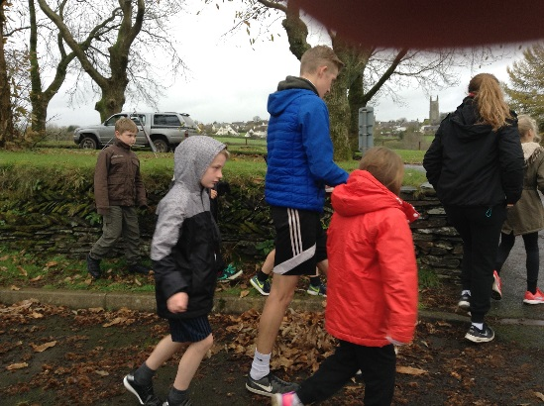
Mrs Mileham
OAK CLASS
FITFOR15
I hope you have all had a chance to look at the Fitfor15 letter which went out yesterday or have had a chat with your children about it.
We are very excited to get some extra exercise into our days and so are the children. We will get the music pumping for extra impetus and maybe the odd pom-pom will be waved by Mrs LDL!
Please help us get this going by ensuring your children bring their P.E. shoes in to school every day. Ideally all children will also have a spare pair of socks in their bags to avoid wet feet for the afternoon as we will be getting outside in most weather.
This initiative is non-competitive and all inclusive. It’s about getting active, having fun and helping all children get plenty of exercise each day. If you have any questions then feel free to come and ask.
Many thanks,
Mr Heagney and Mrs Williams
CONGRATULATIONS
We would like to congratulate Miss Illsley as she is expecting a baby in April.

CHILDREN IN NEED 2017
This year for ‘Children In Need’ on Friday 17th November, children and staff will wear anything spotty for the day for a 50p donation. In conjunction with wearing spots, the children will be hopping, skipping, jumping, running or walking a mile within the school grounds. Children have been given sponsor forms to start collecting. Please could we ask that the remaining monies are handed into school by Friday 24th November. Together lets help change lives of the disadvantaged children and young people throughout the UK.

With deepest Sympathy …
As you may be aware a family within our community has tragically lost a loving husband and father. Steve Rossiter was taken way before his time, at the young age of 44. We send our deepest sympathy to Steve's wife Sarah and 8 year old daughter Ellie who attends our school at this time.
We would like to set up a collection for the family to use as they wish. There will be a collection pot in the school office, please pop in at any time to make donation, I hope you will join us in supporting Sarah and Ellie at this sad time.
HARVEST FESTIVAL COLLECTION
Dear Headteacher, Staff and Pupils
We would like to thank everyone at your school who kindly donated items towards the Harvest Festival collection. Your school collected a total of 28.7 kg for the Foodbank.
The Foodbank relies totally on the support of the local community who give generously to our cause. This year, up until the end of September we have provided 3 days of food to over 2000 people of which 637 were children.
As we are only able to give out what is given to us the continued support of everyone is greatly appreciated.
Kind regards
Diana Laishley-Hayward from The Foodbank
CORNWALL CHRISTMAS BOX
Ginny Daley from the Cornwall Christmas Box appeal visited the school on Monday 6th November to talk to the children about the Cornwall Christmas Box.
To reduce waste paper and promote recycling we would like to ask that instead of exchanging Christmas cards in school this year each class creates a Christmas Food box which will be distributed to vulnerable and impoverished families in Cornwall.
Please see below the Cornwall Christmas Box checklist 2017. Please could you comment on dojo with the item that you will be buying so that we do not double up on too many items;
2x tins of meat
Tin of potatoes
Tin of sweetcorn
Tin of carrots
Jar of cranberry sauce
Gravy granules
Stuffing
Christmas pudding
Mince pies
Packet of custard
Tin of fruit
Packet of yummy, sweet biscuits
Box of chocolates
Packet of 'nibbles' (peanuts or similar)
Chocolate log or Christmas cake
Soft drink (plastic bottle & no alcohol
Our boxes will be distributed through Cornwall county Council to families within our local area.

ANNUAL FLU VACCINATION –
RECEPTION – YEAR 4 – 16TH NOVEMBER 2017
All parents of reception age children to Year 4 should have received an Annual Flu Vaccination letter and consent form. Please return the consent form to the school office even if you do not want to vaccinate your child.

ADMISSION TO A RECEPTION CLASS
SEPTEMBER 2018
If you have a child born between 1st September 2013 and 31st August 2014 you MUST apply for a school place by 15th January 2018. Leaflets are available from the school office or you can apply online at www.cornwall.gov.uk/admissions.

CAR SEAT REGULATIONS
It has come to our attention that not everybody is following the government guidelines regarding car seats. Please can you ensure that all children are seated in the relevant car seat and buckled appropriately?
www.gov.uk/child-car-seats-the-rules

AFTER SCHOOL CLUBS – AUTUMN 2
Please find below our new clubs on offer for our Autumn Term Part 2 starting from Wednesday 1st November:

Monday – Choir – lunchtime 12.30pm-1pm (children will eat lunch first) with Mrs Williams

Monday – Multi Skills with Mrs Berry
3.15pm-4pm

Monday – High 5 with Mrs Mileham
3.15pm-4.15pm

Wednesday- Learning Zone with Miss Teobald
3.15pm – 4.15pm

Thursday – Yoga with Miss Illsley
3.15pm – 4pm

Thursday – Christmas Play with Miss Coffee and Mrs Fox
3.15pm – 4.15pm

Thursday – Football with Mr Le-Doux-Lucas
3.15pm-4.15pm

Friday – ICT Club with Mr Heagney
3.15pm-4.15pm
All children should of received a letter regarding the clubs. Please can you complete and return to the school office if you would like your child to attend any club on offer to their year group.
PARENT PAY
Please can parent’s check their Parentpay accounts for any money owed.

CLAY SCHOOLS FIXTURES -
We are very lucky this year to be participating in the Clays school Football and High 5 leagues. Here the fixtures list:

14.11.17 Luxulyan vs Foxhole School

21.11.17 Luxulyan vs Bugle School

28.11.17 Luxulyan vs Whitemoor

09.01.18 Luxulyan vs Treverbyn

We will confirm on a weekly basis whether the Year 3/4 football match will be happening due to team availability within other schools.

Fixtures maybe changed or cancelled due to typical Cornish weather

PARENTVIEW
On the website, click on the parents tab, then follow the 'Parent View' hyperlink to share your views.
Parent View gives you the chance to tell Ofsted what you think about your child’s school, from the quality of teaching to dealing with bullying and poor behaviour. The survey can be completed at any time; you don’t have to wait until the school is being inspected.
We will use the information you provide when making decisions about which schools to inspect and when.
Click ‘Give your views’ to register and complete a survey to help your child’s school improve.
DIARY DATES
16th November – Reception, Y1,2,3,4 Annual Flu Vaccination
17th November – Children in Need
22nd November -1st December – Music and Speech Festival
23rd – 30th November – Book Fair
1st December – Non Uniform Day

2nd December – Magic Show @ 4pm
Christmas Tableaux @ 5pm
8th December – Christmas Crafts and Disco
15th December – Christmas Play Dress Rehearsal
18th December – Christmas Play at the Church
19th December – Trip to the Cinema
19th December – Christmas Dinner
20th December – Last day of school/Christmas Jumper Day

4th January 2018 – First day back after the Christmas holiday

STAFF TRAINING DAYS – CLOSED TO PUPILS
Friday 20th October 2017
Monday 30th October 2017
Tuesday 31st October 2017

Monday 23rd July 2018
Tuesday 24th July 2018

