Luxulyan School Newsletter

Friday 7th July 2017
ADDRESS: Luxulyan School, Luxulyan, Bodmin, Cornwall, PL30 5EE
TEL: 01726 850397 EMAIL: head@luxulyansch.org WEBSITE: www.luxulyan.eschools.co.uk

Please note some activities/events are not connected to Luxulyan School and parents should undertake their own checks as to the suitability of the providers/activities.

Ash Class
The children have spent some time getting prepared for their transition into Year 1 over the past few weeks. They have been very welcoming to our incumbent Reception children during their visits by showing off the classroom, demonstrating how to use all of our resources and supporting them in the activities. On Tuesday, the children spent the morning in Beech class, where they were able to get used to their new classroom and the daily routine of Year 1. They all had a wonderful time and were very excited to share what they had been doing when they returned.
During our topic learning, the children worked in groups to design, construct and test their own pirate ships for Ash Boat Wars! The winning boat was able to hold all of our mini counting penguins without sinking; congratulations to Team Flash (Harry, Max, Indie, Lara and Toby).
We have been looking at the story of 'The Beastly Pirates' in literacy. The children all took on a role of a different character and enjoyed acting out the story. In maths, we practised using positional language when we went on a hunt for the teddy bears' picnic in our garden.

Miss Illsley and Mrs Rogers
Beech Class
As we head towards the summer holiday, Year 2 have been working on their final DT project of making stories with moving pictures. They have worked hard in English
lessons to create their own version of David McKee's Elmer, and have spent their afternoons working on their artwork for the books, adding in sliders and levers to their pictures to make the stories come to life. They have really used their independence, designing their characters and their settings, and sourcing the correct equipment to put their pictures together. I'm really looking forward to seeing the finished projects as the books are completed over the next couple of weeks.

Miss Coffee

Sycamore Class
Many thanks to all those who supported our ‘Vintage Chocolate Chip Cookie’ stall at the summer fair. The children really enjoyed making around 90 biscuits and

we sold out in the first 45 minutes! We will certainly be making more next year!
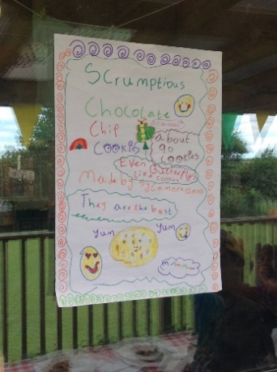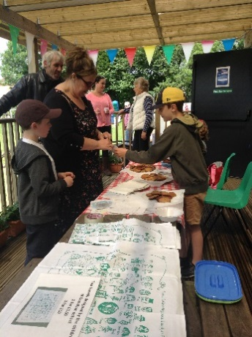
The biscuit project also supported our math topic on measurement which encompassed –money,weight,volume and capacity.
In English the children have been working on producing an opening paragraph for their novel based upon Bear Grylls- The Jungle Adventure. The award winning
paragraph will be published in our final newsletter- so watch this space!!
Mrs Mileham
Oak Class
In the next few weeks of school Oak Class are going to be very busy. Our Cinderellie performance is right around the corner and we have been rehearsing so much it will be amazing on the day- we can’t wait to perform! We will make you laugh and cry! If you enjoy yourself a donation will be much appreciated. So come and see us on Tuesday 18th of July 2pm at the Luxulyan Village hall.
By Elle, Lily, Jamie and Max
SUMMER FAIR
Thank you to everyone who supported this year’s Summer Fair organised by PALS on 3rd July.

Mrs Le-Doux-Lucas

PALS
Just want to say a massive thank you to all the staff and parents that helped at the school fair on Saturday and for everyone who came and supported us we made a brilliant £538 which we hope to get match funded, so thank you all once again.
We are holding out AGM on Tuesday 11th at 7.30pm in the institute be great if some of you could make it.

Suzy Hamilton-Ellery
REPORTS
The class teachers have compiled the annual academic reports which will be sent home on Friday 7th July 2017. The open evening will be on Wednesday 12th July from 3.30pm to 5pm for Reception to Year 5 pupils. Parents are welcome to come along and view their child’s work and teachers will be available to discuss the children’s achievements with you. No appointment is necessary - it will be an informal session.

PARENTVIEW
On the website, click on the parents tab, then follow the 'Parent View' hyperlink to share your views.
Parent View gives you the chance to tell Ofsted what you think about your child’s school, from the quality of teaching to dealing with bullying and poor behaviour. The survey can be completed at any time; you don’t have to wait until the school is being inspected.
We will use the information you provide when making decisions about which schools to inspect and when.
Click ‘Give your views’ to register and complete a survey to help your child’s school improve.
YEAR 6 PERFORMANCE – CINDERELLIE
Our year 6 will be performing their play of Cinderellie on Tuesday 18th July at 2pm at the Village Hall.

END OF SCHOOL DAY
Please be aware that we will not allow children to leave at the end of the school day unless we can see a parent/carer or are informed by the parent that someone else is picking them up.

SUN CREAM AND HATS
In the event of fine weather, please ensure that the children come to school with adequate sun protection, a drink (to have during the day) and a hat, as there is limited shade on our playgrounds and fields.

ABSENT PROCEDURE
Please can parents/carers contact the school office as soon as they know that their child will be absent on a school day.

Also, if you have a planned absence, a holiday, doctor/dentist appointment etc, please can you complete an absence request form which you can obtain from the school office.

WATER BOTTLES
Children to only bring in water in their drinks bottles please.

NHS advice states 'Water is a healthy and cheap choice for quenching your thirst at any time. It also contains no sugars that can damage teeth'.
PRE-SCHOOL SUMMER FAIR
The Pre-School Summer Fair is on Saturday 8th July 10-12 at the Village Hall. Everyone welcome!

DATES
July 10th – EYFS Transition morning
Year 5 iBounce trip
July 11th – Re-scheduled Karate Black Belt trip to Pentewan Beach
July 12th – Report ‘drop in’ feedback sessions all classes – parents welcome 3.30-5pm
July 14th – Gold Band winners trip to Waterstone’s Bookshop
July 18th - Oak class end of Year performance at the Village hall - 2pm. More details to follow.
July 24th - Year 6 leavers assembly at the Village hall- 2pm. More details to follow.
July 26th – Last day of term

Staff Training Days – Closed to pupils
Monday 26th June 2017
Friday 20th October 2017
Monday 30th October 2017
Tuesday 31st October 2017
Monday 23rd July 2018
Tuesday 24th July 2018

