Luxulyan School Newsletter

Friday 19th May 2017
ADDRESS: Luxulyan School, Luxulyan, Bodmin, Cornwall, PL30 5EE
TEL: 01726 850397 EMAIL: head@luxulyansch.org WEBSITE: www.luxulyan.eschools.co.uk

Please note some activities/events are not connected to Luxulyan School and parents should undertake their own checks as to the suitability of the providers/activities.

Ash Class
We have jumped into our new topic 'Let's Get Growing!' this week; beginning with the children planting their own beans. We are going to be observing and recording the progress of our growing beans closely over the next few weeks. Hopefully there will be some wonderful broad bean saplings coming home with the children once we reach the end of our topic! We have enjoyed exploring vegetable printing, looking for wild plants around the school grounds and designing our dream flower gardens. The grown ups weren't sure if all the children had planted a bean, so the children used their maths skills to help us. They added up the all of the potted beans by counting up smaller groups. Our bean diaries will help us keep track of how our beans are growing. This week, the children thought about the steps in planting a seed when writing instructions in their bean diary.

Please continue to send in any examples or photographs of gardening that the children have done outside of school; we love sharing these as a class.

Miss Illsley and Mrs Rogers
Beech Class
Over the last 2 weeks Year 2 have been preparing and taking their end of Key Stage Tests (SATs). Mrs Fox and I could not be more proud of the way the children have prepared for and undertaken these tests. They have worked so hard; concentrating and trying their best whilst at the same time remaining calm about the tests. They have been so positive about the tests and have all been saying how enjoyable the whole experience has been! We have enjoyed our pre-test breakfast, as well as the calming 'Cosmic Yoga' we have taken part in every day too!

Our afternoons have been much more fun; preparing for our Jubilee party this week and learning a little more about Queen Elizabeth and Queen Victoria. We look forward to a more restful final week of term next week!

Miss Coffee

Sycamore Class
Ethan and Tegan showing off their ‘Habitat Shoe Boxes’
Sycamore class have had a fun fortnight of learning. The children researched habitats and created their own mini versions. (Many thanks for all the unwanted shoe boxes)
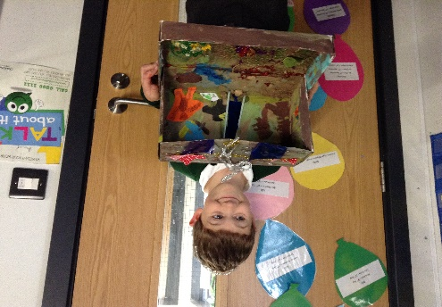
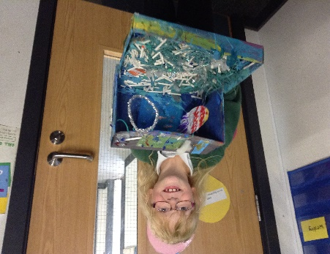
They also posed some very interesting question to Reverend Jules on the subject of the Trinity, explored informal letter writing and tested their reasoning skills with time in Mathematics, much of which was experienced outside in the sunshine.
Unfortunately, due to the adverse weather, our trip to the Luxulyan Valley had to be cancelled but has been rescheduled for next Wednesday 24th May (Weather permitting of course).
Mrs Mileham
Oak Class
During SATS week Oak class were making natural disaster animations. On Monday, we were put into groups of 3 and we decided our natural disaster for our animation. We were given a cardboard box and we had to make a background using paper and paint. When we had finished, we had to make our characters or props that we needed to use. All of this had to be made out of plasticine. The next day, we had to take pictures with lots of slow movements before downloading them onto a website called ZU3D. It was excellent fun. After a lot of hard work putting together the animations we eventually finished them with music and everything else that made them so amazing. Finally after so much work we completed our amazing animations ready to show at our Oak class open afternoon!
By Lily T and Holly T
Goodbye to……………………
All the staff would like to say a Big Thank you to Mrs Panayi for all of her hard work and dedication while at Luxulyan School.
She will be greatly missed and we wish her well. Her last day will be Friday 26th May.

PALS
We are holding our next meeting on Tues 23rd May at 7.30pm in the institute. It would be great if you could make it. We will be discussing ideas for the Summer Fayre so even if you can't attend the meeting but have some ideas please let one of our committee members know.
There is non uniform day on the 26th May in exchange for a bottle for the tombola for the fayre.
Thanks for your continued support.
Suzy Hamilton-Ellery
NEW RECEPTION INTAKE PARENTS MEETING
On Thursday 25th May we have invited our new reception intake parents to a meeting to introduce the teaching staff, share information about what to expect once their child starts school and answer any questions they may have.
There will also be a stay and play morning on Friday 23rd June to support the children and ease them gently into their new school life. Parents will be welcome to enjoy a tea or coffee and maybe a biscuit!
PHONICS SCREENING
Phonics screening for Years 1 and 2 will commence week beginning 12th June.
PARKING ON THE DOUBLE YELLOW LINES/ZIG ZAG LINES
Please can we ask again for parents NOT to park on the double yellow lines outside of the school gates.

We have alerted our local PCSO on this matter.

YEAR 6 ROYAL CORNWALL SHOW TRIP
To celebrate the end of KS2 SATS, the Year 6 students, along with Mr Heagney and Mrs Fox will
be visiting The Royal Cornwall Show on Friday 9th June 2017. They raised money during their Enterprise week which helped pay towards the cost of the trip’s transport.

PCSO VISITING THE SCHOOL
On Wednesday 24th May PCSO Jamie Ward will be visiting the school during assembly. This will give the children an opportunity to ask him any questions.

SCHOOL PHOTOGRAPHS
The School Photography Company is coming to Luxulyan School on 7th June to take photographs of each class.

LOST PROPERTY
We have lots of lost property so please feel welcome to look through it, if your child has lost any items.

Please make sure you send named clothes, drinks bottles etc to school.

SCHOOL UNIFORM REMINDER
Please can you ensure your child comes to school in the correct uniform. Please contact the office if you are unsure of the correct uniform specification.

DELAWARE OUTDOOR EDUCATION CENTRE CAMP – OAK CLASS
The pupils of Oak Class who are attending the Delaware residential stay visit are looking forward to their trip on 12th-14th June 2017.

KARATE READING
The final day of counting for 120 reads = Black Band is on Friday 26th May. All children who have reached this milestone will be awarded with a beach trip. Reading bands will continue to be awarded till the end of the Summer term.

Extreme reading – The last entries for Extreme reading photos need to be in by Friday 26th May. Prizes will be awarded in assembly after half term.

PARENTVIEW
On the website, click on the parents tab, then follow the 'Parent View' hyperlink to share your views.
Parent View gives you the chance to tell Ofsted what you think about your child’s school, from the quality of teaching to dealing with bullying and poor behaviour. The survey can be completed at any time; you don’t have to wait until the school is being inspected.
We will use the information you provide when making decisions about which schools to inspect and when.
Click ‘Give your views’ to register and complete a survey to help your child’s school improve.

EDEN PROJECT VISIT – SYCAMORE CLASS
Sycamore class are planning a visit to The Eden Project on Tuesday 20th June. More details to follow.

LUXULYAN FEAST WEEK – 18-24 JUNE 2017
There are lots of exciting events planned including:

- Sunday 18th - A cake Decoration Competition at Kings Acre at 3pm.

- Monday 19th 6pm – Rounders in the Village Hall field followed by a BBQ

- Tuesday 20th 6pm-7.30pm - ‘Children’s Sports’ on the school field followed by BBQ.

- At 7.30pm ‘A meal cooked by children from Luxulyan School’ will be prepared, cooked and served by the children at Kings Arms. Please phone 01726 850202 to make your reservation.

- Friday 23rd 4pm-5.30pm – Children’s Party at the Village Hall

- Saturday 24th 5pm – ‘Luxulyan’s Got Talent’ at the Kings Arms Carpark then a BBQ.

- 6pm – Ball Race then ‘Point Blank’ playing in the car park.

Full details of the weeks planned activities are available on Luxulyan Feast Week page on Facebook.

DATES

May
May 25th - New intake parents meeting

June
June 7th – Class Photographs
June 9th – Royal Cornwall Show trip– Year 6
June 12th-16th Phonics Screening Year 1/2
June 12th -14th- Delaware camp
June 20th – Sycamore Eden visit
June 21st- Sports Day (if weather permits)
June 23rd – Stay and Play
June 26th - Staff training day INSET
June 27th - Back up sports day if needed
June 29th – Whole School Bread Workshop (Chartwells)

July
July 1st - Summer fayre 11am – 1pm
July 3rd – EYFS Transition morning
July 3rd/4th – Penrice Welcome Days
July 4th – Move Up Morning – Whole School 9-12
July 10th – EYFS Transition morning
July 12th – Report ‘drop in’ feedback sessions all classes – parents welcome 3.30-5pm
July 20th- Oak class end of Year performance at the Village hall - 2pm. More details to follow.
July 24th - Year 6 leavers assembly at the Village hall- 2pm. More details to follow.

Staff Training Days – Closed to pupils
Monday 26th June 2017
Friday 20th October 2017
Monday 30th October 2017
Tuesday 31st October 2017
Monday 23rd July 2018
Tuesday 24th July 2018

