Luxulyan School Newsletter

Friday 5 May 2017
ADDRESS: Luxulyan School, Luxulyan, Bodmin, Cornwall, PL30 5EE
TEL: 01726 850397 EMAIL: head@luxulyansch.org WEBSITE: www.luxulyan.eschools.co.uk

Please note some activities/events are not connected to Luxulyan School and parents should undertake their own checks as to the suitability of the providers/activities.

Ash Class
Ash class have had some unwelcome visitors this week…the evil peas from the Supertato stories invaded our classroom and outdoor area! Thankfully, the children transformed into superheroes and managed to save us all. They wrote warning signs to let others know where the peas were lurking, helping us all to stay clear of them.
In Maths, the children hunted through the garden and managed to capture all of the peas. Some of us even managed to rescue some of the poor captured vegetables! After collecting all of the evil peas, we counted them into smaller groups and marched them straight back to the freezer. Phew!
After the excitement of this week’s events, the children have written newspaper reports to inform the rest of the school about what happened. Thank goodness that the children of Ash class saved the day! We have continued to enjoy our Superheroes topic. The children have made superhero potions, visited the superhero gym and used clay to model their own super characters.
In a few weeks we will be starting our new topic, based on planting and growing. If any of the children have been gardening at home, we would love to see their plants, or a photo of what they’ve been growing.
Miss Illsley and Mrs Rogers
Beech Class
We have been focussing on our upcoming KS1 SATs in Year 2 recently. The children have been working very hard and I'm really proud of how hard working and resilient they are. In Year 2 over the next few weeks we will be making formal assessments. This is kept very low key, as part of normal classroom activities and will be administered by Class 2 staff. In Key stage 1, SATS materials are used to confirm our teacher assessment only. Teacher assessment is based upon performance as a whole over a period of time. It is not just about the formal assessments that are made over the next few weeks or how a child performs on one particular day. We will make teacher assessments in English, Maths and science. The children are given the opportunity to become familiar with these assessment materials and procedures. Many of the tasks are just like activities they experience each week and can be based on the class theme. Over the week beginning Monday 15th May, the week will be organised slightly differently to accommodate how assessments are carried out. As a school we ensure that this is done in a calm and positive way to ensure that all children feel comfortable. All staff endeavour to make this a stress free time and we ask that you support us with this. Each morning before the tests start, we will be offering the children a special 'SATs breakfast' to settle themselves into the day. During the afternoons over SATs week, we will be focussing on preparing for our Sapphire Jubilee Tea Party in order to ensure the children have a fun and enjoyable week, with the reward of the Tea Party at the end of the week. If you have any further questions then please come in and see me.

Miss Coffee

Sycamore Class
Sycamore took advantage of the glorious sunshine to go on a bug hunt last week where they discovered some interesting habitats!
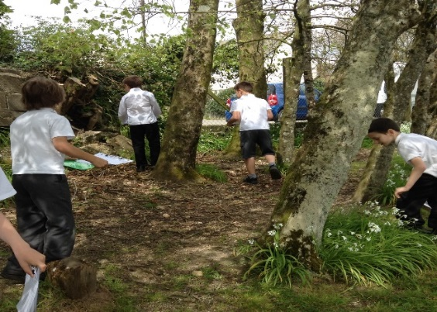
Outside learning has also included some tricky measuring; finding the perimeter of the playground and playing field as well as telling the time on a giant play- ground clock.
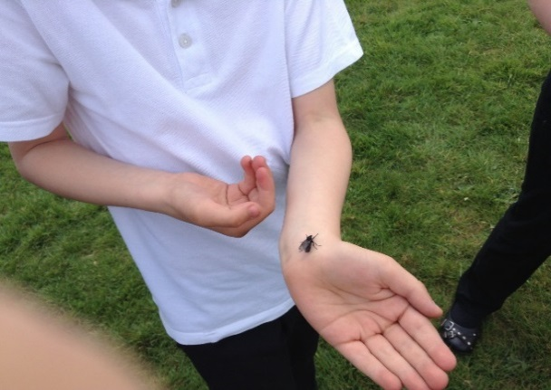
To extend our Science/Art/DT topic even further we desperately need some shoe boxes as we propose using them to make mini habitats. If you have any at home please bring them to Sycamore class as soon as you can.
Many thanks
Mrs Mileham
Oak Class
This week Year 5 and 5 have been split as Year 6 have been working hard completing practice SATS in preparation for next week. This has been really helpful for us. The teachers have made sure that we had some fun lessons in the afternoon though!

Taylan Brewer and Jay Buckland
SOME USEFUL SATS ADVICE
- Don’t panic!
- Try your best.
- Make sure you get a good night’s sleep and have a good breakfast (we are running a breakfast club every day at 8.30am)
- Read each question carefully
- Remember you’ve been blessed with skills that SATS don’t test!

During Maths, Year 5 have been completing a spirolateral investigation using our knowledge of times tables to generate number sequences. We’ve had great fun and are looking forward to completing our fantastic classroom display!

Oakley Holmes and Jamie Webster

PALS
Just want to say a massive thank you to everyone who came and supported our May Day tea party last week. It was lovely to see all of you there and for all the lovely cake donations that were made. We raised a brilliant £240.74.
Thank you all so much.
The new minutes will be available soon on the website for all to see.
Thanks
Suzy Hamilton
KEY STAGE 2 SATS
The Year 6 SATS will take place next week. The children have been working hard in preparation and all they need to do now is make sure they
show what they can do. We all wish them well and just want them to do their best.
PARKING ON THE DOUBLE YELLOW LINES/ZIG ZAG LINES
Please can we ask again for parents NOT to park on the double yellow lines outside of the school gates.

We have alerted our local PCSO on this matter.

AFTER SCHOOL CLUBS
Just a reminder that there are no After School Clubs week beginning 8th May due to KS2 SATS.
TOYS
Just a reminder, please do not allow children to bring toys into schools.

NEW MEMBER OF STAFF
We welcome Mr Cook as our new Site Manager. He has replaced Mr Brooks and will be working at the school on a part time basis.

HEADLICE
We are still observing head lice amongst our pupils. We urge ALL PARENTS to check your child(ren)’s head for any signs of head lice. If live lice are found, the wet combing method should be used every 2-3 days for at least 2 weeks (to break the life cycle of head lice) until the problem is cleared. All family members should be
checked and treated if necessary. We suggest that checks should then continue to be made on a weekly basis to prevent any further infestations.

PHONICS SCREENING
Phonics screening for Years 1 and 2 will commence week beginning 12 June.

SCHOOL PHOTOGRAPHS
The School Photography Company is coming to Luxulyan School on 7 June to take photographs of each class.

SUNHATS AND SUN CREAM
When it looks like being hot and sunny, the cancer prevention people would like you to ‘slip, slap and slop’ to protect your children. Please put their names in their hats!

DATES

June
June 7th – Class Photographs
June 12th-16th Phonics Screening Year 1/2
June 12th -14th- Delaware camp
June 21st - Sports Day (if weather permits)
June 26th - Staff training day INSET
June 28th - Back up sports day if needed

July
July 1st - Summer fayre 11am – 1pm
July 3rd – EYFS Transition Day
July 4th – Move Up Morning
July 20th- Oak class end of Year performance at the Village hall - 2pm. More details to follow.
July 25th - Year 6 leavers assembly at the Village hall- 2pm. More details to follow.

Staff Training Days – Closed to pupils
Monday 26 June 2017
Friday 20 October 2017
Monday 30 October 2017
Tuesday 31 October 2017
Monday 23 July 2018
Tuesday 24 July 2018

JOB ADVERT
CLEANER REQUIRED TO CLEAN LUXULYAN VILLAGE TOILETS
If you are interested please contact the Clerk for an information pack and job description.
The Clerk
Luxulyan Parish Council
Lower Burlorne
Tregoose
Washaway
Bodmin
PL30 3AJ
clerk@luxulyanpc.co.uk

