Luxulyan School Newsletter

Friday 23rd June 2017
ADDRESS: Luxulyan School, Luxulyan, Bodmin, Cornwall, PL30 5EE
TEL: 01726 850397 EMAIL: head@luxulyansch.org WEBSITE: www.luxulyan.eschools.co.uk

Please note some activities/events are not connected to Luxulyan School and parents should undertake their own checks as to the suitability of the providers/activities.

Ash Class
We are continuing to enjoy our ‘Seaside’ topic and the warm weather has certainly helped bring it to life! The children have been learning to sing ‘The big ship sails’, thinking about rests in the music and changes in speed. In English, we wrote messages for the pre-school children who are joining the school in September. We thought about how we felt when we started in Ash class, who we met and we what we enjoyed playing with. In maths, we have been learning about positional language and direction. It was great fun programming the beebots to make full and half turns.
Please can we remind parents and carers that the children continue to have spellings to learn until the end of term. We appreciate the time you spend practicing these with them at home. They enjoy having a go and it helps to prepare them for spelling homework in Year 1. Thank you.
Miss Illsley and Mrs Rogers
Beech Class
Class 2 have worked very hard over the last two weeks. Particular praise must go to the Year 1 children who worked so hard on their phonics screen at the start of last week. They approached it with smiles and determination and all tried their hardest; Mrs Fox and I are very proud. Aside from phonics we have been practising a lot for sports day which was a great success and again, all the children joined in, took part and cheered each other on really Well. Our Year 2’s have really enjoyed learning about African animals and the food chains and webs they form part of. We have also had some Year 6 visitors for a few days who were an excellent help, and joined in with some amazing artwork.
Miss Coffee

Sycamore Class
The highlight of the last fortnight for Sycamore class has got to be our visit to the Eden Project to have a go at the ‘Rainforest Rangers’ challenge. I am so proud of Sycamore class as they persevered in temperatures of 45 degrees in the 50-metre-tall Biome House. They discovered how to survive in the tropical rainforest of South America: what they could eat; how they would collect their water and finally what they would use for shelter.
Pictures show children on the Rainforest canopy walkway
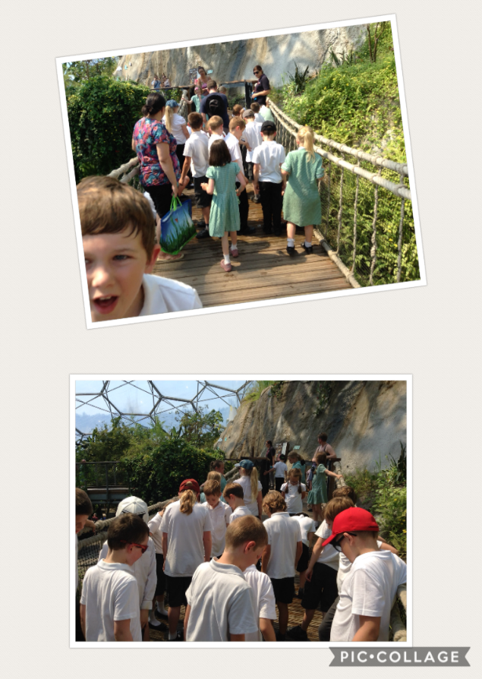
We even experienced cross-curricular links to our maths topic on Geometry with the children recognising the pentagons and hexagons of the Eden Project’s biome structures!
Mrs Mileham
Oak Class
Last week Oak Class went on their summer camp to Delaware Outdoor Adventure Centre where we took part in a number of different fun activities including rock climbing and canoeing. After lunch on the first day we went on an adventurous moorland walk across Dartmoor which was really exciting. When we got to the top of Kings Tor there was a surprise in store- we had to climb and squeeze through a number of small gaps between the rocks like weasels- the instructors told us it was called ‘weaselling’! Each challenge had a name like ‘Leap of Faith’ or ‘Toothpaste Tube’ and the gaps increased in difficulty but despite some of us not being quite sure if we could do it or not we all made it through the gaps by supporting each other and working as a team. It was great fun!

The second day was spent up at Kit Hill where we had to climb three spectacular rock faces in the morning. Many of us were scared and nervous and not sure we could do it but we couldn’t believe it when we realised we had finally made it to the top. In fact it made some of us want to have another go! In the afternoon we had an incredible time canoeing in the quarry. We all learnt from the instructors how to hold the paddle and row correctly and it quickly became clear that you needed to work as a team to make sure you didn’t end up in the water! By the end of the session we were all thoroughly soaked and needed to have a shower but we didn’t care as we had such a great time.
On the final morning we had an archery contest which was a really nice way to end our camp. We learnt how to fire the bow and arrow correctly and we even got to go out to the back field and fire volleys of arrows as if we were in a battle which was exciting. It turns out we have some pretty good archers in Oak Class!
We had such a good time that we were a little sad when we realised it was time to return back to school. We are already looking forward to what our next adventure might be…
By Evie G and Oakley H
SPORTS DAY
Sports day - What an amazing Sports Day! All of the children showed fantastic teamwork and ‘sportspersonship’.
It was great to see everyone taking part and supporting each other.
Thank you to all the staff in their various roles for supporting the children to have an amazing day.
Thank you to PALS for providing refreshments at KS1 and KS2 Sports day.
Mrs Fox

PALS
It won't be long until our Summer Fair which is 1st July 11-1pm, if anybody can help out in anyway even if it's making tea and coffee for 10mins that would be fantastic. If you could let me know if you are free to help it's much appreciated.
If anyone would like a stall at the Fair please contact me or alternatively the school office who will pass on your message. Stall cost £5 each.
Thanks
Suzy Hamilton-Ellery

MASTER CHEF COMPETITION
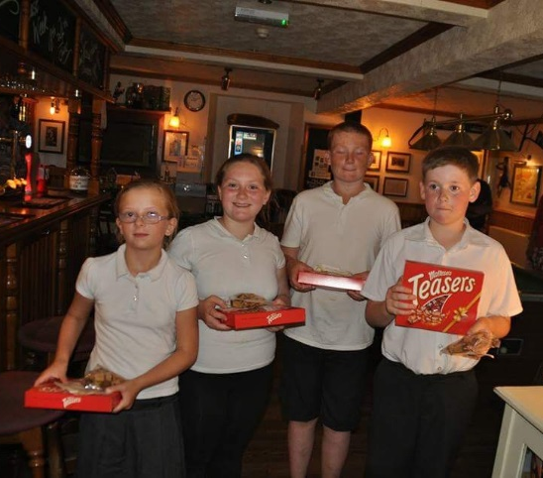
On Tuesday myself and Miss Coffee supported the year 6 children in cooking over 30, three course meals at the Kings Arms.

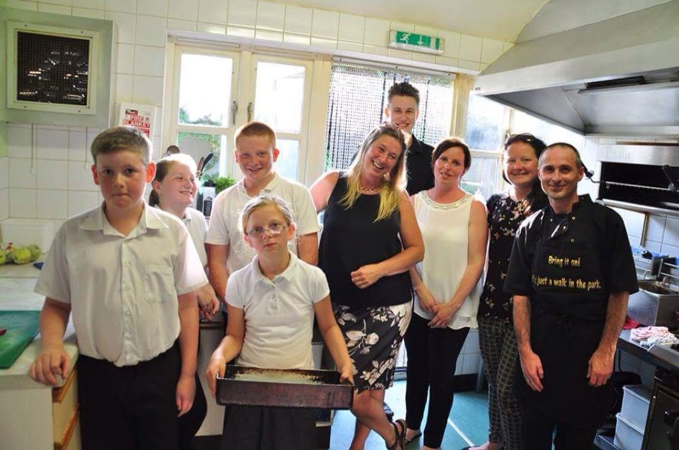
The children were amazing and the compliments kept pouring in. Very talented group of children who all have a future in catering
Missing is Max L who helped with the menu choices and practised cooking the starters and desserts in practice sessions - you were missed.
We raised over £300!
Well done all, big thank you to Miss Coffee for giving up your evening.
Mrs Fox
END OF SCHOOL DAY
Please be aware that we will not allow children to leave at the end of the school day unless we can
see a parent/carer or are informed by the parent that someone else is picking them up.

WHOLE SCHOOL BREAD WORKSHOP- THURS 29TH JUNE.
Classes will experience a bread workshop, which will be run by Chartwells who currently provide Luxulyan's school meals.

ABSENT PROCEDURE
Please can parents/carers contact the school office as soon as they know that their child will be absent on a school day.

Also, if you have a planned absence, a holiday, doctor/dentist appointment etc, please can you complete an absence request form which you can obtain from the school office.

SCHOOL UNIFORM POLICY
Please can you ensure your child comes to school in the correct uniform. Please see below the school uniform policy:
- A bottle green top embroidered with the Luxulyan School logo. Parents may choose from the various styles as follows:
  - Full zip fleece
  - Sweatshirt – crewneck or V neck
  - Sweat cardigan
  - Cardigan
- Grey or black trousers or skirts/pinafores
- White shirts/blouses or polo shirts (long or short sleeved) – but not T-shirts
- For summer: children may wear formal (not casual) grey/black shorts instead of long trousers, and girls may also wear checked/striped green and white dresses
- School shoes need to be black. No boots. Trainers are not to be worn, except for PE.
Sandals can be worn in the warmer weather – but not ‘flip-flop’ types, ‘Reefs’ or ‘Crocs’, as they are not suitable for the school environment.

WATER BOTTLES
Children to only bring in water in their drinks bottles please.
NHS advice states 'Water is a healthy and cheap choice for quenching your thirst at any time. It also contains no sugars that can damage teeth'.

INSET DAY – MONDAY 26TH JUNE 2017
Just a reminder, due to staff training, school will be closed to pupils on Monday 26th June 2017.

CLUB REMINDER
Please can you let the school office know if your child cannot attend an after school club.

LUXULYAN FEAST WEEK – 18th-24th JUNE 2017
There are still lots of exciting events planned including:
- Friday 23rd 4pm-5.30pm – Children’s Party at the Village Hall

- Saturday 24th 5pm – ‘Luxulyan’s Got Talent’ at the Kings Arms Carpark then a BBQ.

- 6pm – Ball Race then ‘Point Blank’ playing in the car park.

Full details of the weeks planned activities are available on Luxulyan Feast Week page on Facebook.

DATES
June
June 26th - Staff training day INSET
June 29th – Whole School Bread Workshop (Chartwells)

July
July 1st - Summer Fair 11am – 1pm
July 3rd – EYFS Transition morning
July 3rd/4th – Penrice Welcome Days
July 4th – Move Up Morning – Whole School 9-12
July 10th – EYFS Transition morning
July 12th – Report ‘drop in’ feedback sessions all classes – parents welcome 3.30-5pm

July 18th - Oak class end of Year performance at the Village hall - 2pm. More details to follow.
July 24th - Year 6 leavers assembly at the Village hall- 2pm. More details to follow.
July 26th – Last day of term

Staff Training Days – Closed to pupils
Monday 26th June 2017
Friday 20th October 2017
Monday 30th October 2017
Tuesday 31st October 2017
Monday 23rd July 2018
Tuesday 24th July 2018

