Marvellous Me Box

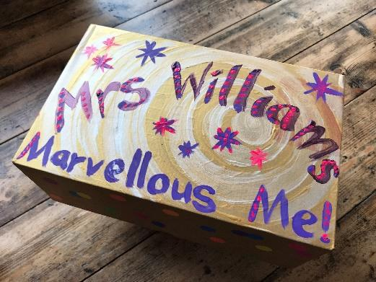
Please create a box with your child containing special items and photos that they have chosen. As they choose the contents of the box, talk about why they are significant to them.

During circle time, in the first few weeks, each child will be encouraged to share the contents of their box. The other children will be encouraged to ask questions and find out more about their classmate.

Why do we do it?

- It is a great way to start to get to know each child.

- It encourages your child to talk in their new setting.

- It starts to build the children’s understanding that everyone is an individual with their own likes and dislikes.
- The familiar objects/ photos can be used to provide comfort to the child if they become upset.
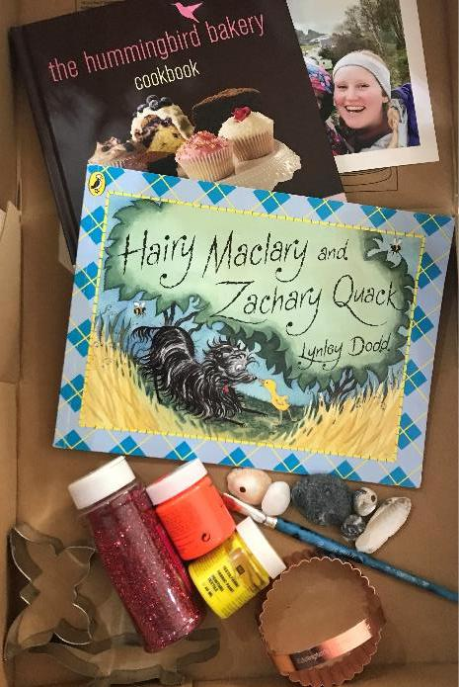

Ideas

The contents might include photos and items that show their family, pets, favourite toys or books, home, where they have been on holiday – things that will get the children talking.

If you have time, please write a note about the items in the box so that we can support your child to talk about them.

The Practicalities

- The lid must close on the box

- Shoe box sized box

- Between 4-6 items in the box

- Please decorate the outside of the box and include your child’s name.

- We strongly suggest that nothing of emotional or monetary value is included as although the children are encouraged to handle items carefully, accidents can happen. Perhaps include a photo of these items instead.

- Send them in during the first week of term.

- Please do not include anything your child needs daily (include a photo instead).

We look forward to seeing what you choose!

